**Functions of Single Variable:**

**i)Rolle’s Theorem**

**ii)Lagrange’s Mean value theorem.**

**iii)Cauchy’s mean value theorem**.

1. **Rolle’s Theorem and its proof.**

If f(x) is a function continuous in the closed interval [a,b]

If f(x) is a function derivable in the open interval (a,b)

If f(a)=f(b)

Then Rolle’s theorem states that at least one value of x say c in the open interval (a,b) such that f’(c)=0

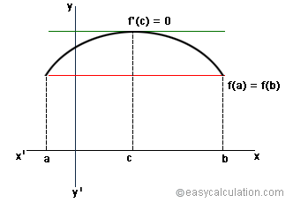

Proof: Since f(x) is continuous in the closed interval [a,b], so it is bounded and we assume the greatest value of f(x) in the interval is M.-

And least value of f(x) is m ,

We have to prove f’(c)=0 ,since f(c)=M

As f’(c) exists, => Rf’(c) = Lf’ (c) = a finite no,

Since f’( c) =M (The greatest value of f(x) in (a,b)

If we move left or right ,the value is less than or equal to M

Then f(c+h)-f(c) ≤ M

If h>0 then $\frac{f(c+h)-f(c) }{h}$ ≤0 (The numerator is either zero or negative) and if denominator is positive total quantity is negative or zero.

Similarly If h<0 then $\frac{f(c+h)-f(c) }{h}$ ≥ 0 Taking limits h->0+ and

h->0-,

We get that Rf’(c)=Lf’( c)= f’( c)=0

Problem Number 1: If f(x)=(x-a)m(x-b)n where m and n are positive integers , show that c in Rolle’s theorem divides the segment a≤x≤b in ratio m:n.

f(x) is continuous in a≤x≤b

f’(x)=m(x-a)m-1(x-b)n + (x-a)mn(x-b)n-1

=(x-a)m-1(x-b)n-1 [m(x-b)+n(x-a)]=0

m(x-b)+n(x-a)]=0

mx-mb+nx-na=0

(m+n)x=mb+na

x= $\frac{mb+na}{m+n}$

So the point c divides the interval in the ratio m:n

1. **Mean value theorem (Lagrange’s form)**

If f(x) is a function continuous in the closed interval [a,b]

If f(x) is a function derivable in the open interval (a,b)

Then there exists at least one value of x say c in (a,b) such that

f’(c)= $\frac{f(b)-f(a) }{b-a}$

The fraction $\frac{f(b)-f(a) }{b-a}$ measures the average rate of change or increase of the function in the interval of length (b-a).

So under certain conditions the mean rate of increase is the actual rate of increase of the function at a certain point.

Numeri

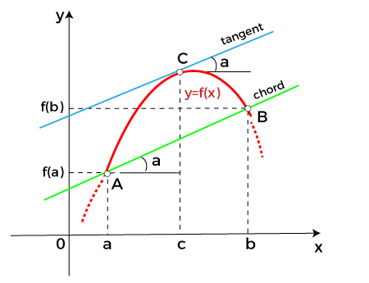

Suppose on x axis the difference between a to b or (b-a) is assumed as ‘h’, so any intermediate point from a to b is length of oa added with θ(b-a) ,which is a + θ(b-a) or

a+ θ h Where θ ranges between 0 to 1, or 0< θ<1.

So intermediate point c can be represented as

f’(a+ θ h)= $\frac{f(b)-f(a) }{h}$

or h.f’(a+ θ h)= f(b)- f(a)

or f(b)= f(a)+ h.f’(a+ θ h)

This concept can be used for Numerical Approximations.

Problem Number 2: Use mean value theorem prove that $\sqrt{101 }$ lies between 10 and 10.05.

Now from initial observation use Mean Value Theorem on

f(x)= $\sqrt{x}$ in [100,101]

f(x) in [b,a] we know that

f’(x)= f’(a+ θ h)= $\frac{f(b)-f(a) }{h}$

Here b=101 , a=100, h=(101-100),

So f(b)=f(a)+h.f’(a+ θ h)

f(101)=f(100)+(101-100) $\frac{1 }{2\sqrt{100+θ .1}}$ < 10+ $\frac{1 }{2.10}$ =10.05

**Proble1m** 3: Use Mean value theorem to prove that $\sqrt[3]{28}$ is less than 3. $\frac{1}{27}$.

Instead of 28, we consider the variable x for estimation and take the interval as [27-28]

Sop f(28)=f(27)+(28-27)f’(x1) where 27<x1<28

Now f(x)= $x_{3}^{1}$ and f’(x)= $\frac{1}{3}x^{-\frac{2}{3}}$

S0 $\sqrt[3]{28}$ = $\sqrt[3]{27}$ + $\frac{1}{3.(27)\frac{2}{3}}$

$\sqrt[3]{28}$ <3+ $\frac{1}{.(27)}$

Problem Number:4

Using Mean value theorem show that

$\frac{x}{1+x}$ <log(1+x)<x for all x >0

As per Lagrange’s theorem f’(c)= $\frac{f\left(b\right)-f(a)}{b-a}$

If the interval is [0,x]

Then c= 0+θx

Where θ is 0<θ<1

f’(θx)= $\frac{f\left(x\right)-f(0)}{x-0}$

or f(x)= f(0)+ xf’(θx)

Now f(x)=log(1+x) then f(0)=0

And f’(θx)= $\frac{1}{1+θx}$

So f(x)= f(0)+ xf’(θx)=0+ x.f’(θx)= $\frac{x}{1+θx}$

Now at the denominator the value is (1+θx) , so the value is 1+ some value between 0 to 1 multiplied with x ,which is greater than 1. If denominator increases total value decreases. So $\frac{1}{1+θx}$ is less than $\frac{x}{1}$ because in case of x the denominator is only 1 and as denominator is less the value is more and $\frac{1}{1+θx} is$ more than $\frac{1}{1+x}$,here at the denominator, the value 1 is multiplied with x.

Cauchy's Mean-Value Theorem

Cauchy's mean-value theorem is a generalization of the usual [mean-value theorem](https://mathworld.wolfram.com/Mean-ValueTheorem.html). It states that if f(x) and g(x) are [continuous](https://mathworld.wolfram.com/ContinuousFunction.html) on the [closed interval](https://mathworld.wolfram.com/ClosedInterval.html) [a,b], if g(a)!=g(b), and if both functions are [differentiable](https://mathworld.wolfram.com/Differentiable.html) on the [open interval](https://mathworld.wolfram.com/OpenInterval.html) (a,b), then there exists at least one c with a<c<b such that

|  |
| --- |
| (f(b)-f(a))/(g(b)-g(a))=(f^'(c))/(g^'(c)) |

Problem Number:5 then prove c is the arith

If f(x)= $e^{x}$ and g(x)= $e^{-x}$ thmean between a and b.

Or as per Cauchy’s theorem $\frac{e^{b}-e^{a}}{e^{-b}-e^{-a}}$ =

$e^{a}e^{b}$ x $\frac{e^{b}-e^{a}}{e^{-b}-e^{-a.}(e^{a}e^{b})}$ =-ea+b

= == - or 2c= a+b

So c= $\frac{a+b}{2}$